

Romanian Academy

"Sabba S.Ştefănescu" Institute of Geodynamics
19-21, Jean-Louis Calderon St., Bucharest-37, Romania, R-020032,
fax:(4021)317.21.20, tel. (4021)317.21.26 e-mail: inst_geodin@geodin.ro www.geodin.ro/~prezentare

Brief History

The "Sabba S. Stefanescu" Institute of Geodynamics of the Romanian Academy (IG"SSS"AR) was constituted in 1990, simultaneously with the revival of the Romanian Academy. At its constitution, the Institute was based on the Laboratory of Geodynamics and the research group for natural fields, which used to be, together with a Laboratory of Seismology and a Laboratory of Rock Mechanics, parts of the Centre of Earth Physics and Seismology. The latter became in 1990 the National Institute for Earth Physics.
The Institute continues a tradition begun in the framework of the Geophysical Research Centre of the Romanian Academy when, on the occasion of the February 15, 1961 total solar eclipse, it may be considered that experimental Geodynamcis was introduced in our country. On the occasion of this eclipse, in a building belonging to the Caldarusani monastic complex the first recordings of the variations in time of the gravitational field in our country were carried out, using as a sensor an Askania type gravimeter and recording systems of own construction.

Director:  Dr.Crisan Demetrescu  Corresponding member  of the Romanian Academy  (crisan@geodin.ro)  Deputy Director:  Dr.ing.Dumitru Stanica  (dstanica@geodin.ro)  Honorary Director:  Dr.ing.Dorel Zugravescu,  Corresponding member  of the Romanian Academy | 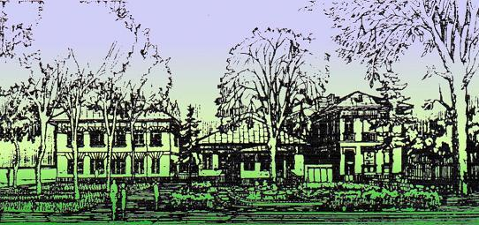

Structure:

Laboratories: 6
Administration: 3

Human resources:

91 employees, out of which 47 research staff.

Research Directions

Since its foundation, the Institute of Geodynamics "Sabba S. Stefanescu" of the Romanian Academy focused its interest on fundamental research imposed by the tasks implied by the Priority Program of the Romanian Academy, "Complex geophysical research in geodynamically active areas concerning especially the Vrancea seismogenic area", regarding particularly:
- the study of space-time variations of some parameters causally linked to the accumulation of stresses responsible for earthquakes occurrence;
- crustal deformations monitoring (relative displacement of tectonic blocks);
- tectonic hazard studies;
- the monitoring of space-time variations of the gravitational, geomagnetic, geoelectric fields and of earth crust tilts;
- the creation and permanent maintaining at an international level of a mobile specialized equipment for complex studies in geodynamically active areas (seismoactive areas, landslides, underground cavities collapses, areas that became geodynamically active because of anthropogenic activity);
- modeling of the thermo-mechanical evolution of the lithosphere;
- non-linear analysis of geodynamic systems;
- own construction of equipment designed for monitoring of geodynamic phenomena: tiltmeters, horizontal/vertical pendulums, extensometers, etc.

Research Infrastructure

At present, the Institute has a network of observatories and observation points, structured in profiles and geodynamics polygons, all having as a main purpose a better knowledge of phenomena leading to stress cumulating/earthquake triggering in geodynamically active areas, with a special concern for the geodynamically active area of the Romanian Carpathians bend - the Vrancea seismogenic zone. The network is concentrated in three geodynamics polygons: the Caldarusani-Tulnici Geodynamics Polygon, the Craciunesti-Deva, Sarmizegetusa Regia, Pades-Gorj Geodynamics Polygon and the Danube Delta - Mangalia Geodynamics Polygon.

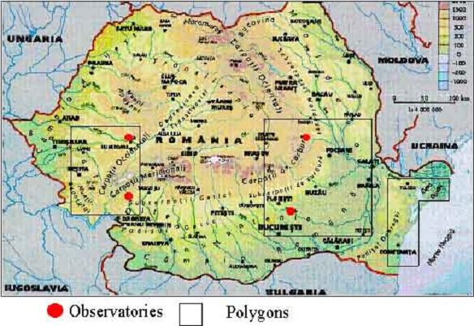 | 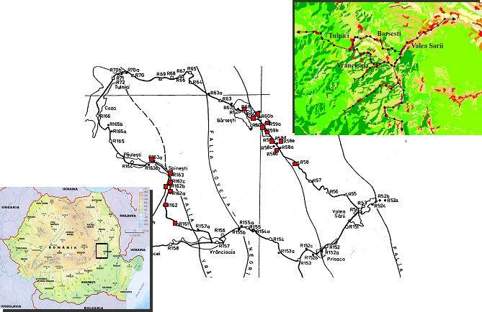  The location of the Vrancea Natural Laboratory for Geodynamics

Among these polygons, a special place is occupied by the Caldarusani-Tulnici Geodynamics Polygon which includes - besides the laboratories for equipment gauging and aging, arranged in the framework of the Caldarusani Geodynamics Observatory, in the basement of the group of buildings that constitute the headquarters of the IG"SSS"AR, and in the basement of the headquarters of the Romanian Academy - several micropolygons consisting of over 200 observation points, that allow the performing of repeated measurements, usually at 6 months up to 5 years intervals, and of underground laboratories, which allow data acquisition - within the limits of the possible, without interruption - corresponding to variations in the crust tilt and in the gravity, the magnetic and the electric fields in Vrancea area.
Among these micropolygons, the most important one - the Micropolygon I Tulnici - is situated in the Vrancea geodynamically active area on both sides of the contact on which the hypocenters of the Vrancea seismogenic area are situated, to a depth that may exceptionally exceed 180 km.
We underline the fact that at present, the Caldarusani Geodynamics Observatory is functioning in the building where recordings were carried out on the occasion of the total solar eclipse in February 1961 and that the co-operation established in 1961 between the Caldarusani Monastery - the Romanian Orthodox Church and the Caldarusani Geodynamics Observatory (the Geophysical Research Centre) - the Romanian Academy, was officially celebrated in 2001, at the anniversary of four decades of existence of the first and up to now the only co-operation established between one of the orthodox churches - the Romanian Orthodox Church - and science - the Romanian Academy.
The Craciunesti-Deva, Sarmizegetusa-Regia, Pades-Gorj Geodynamic Polygon is constituted, in its northern part, of a set of underground observatories including laboratories situated at depths exceeding sometimes 100 m below the soil surface, where the sensors are located far from any influences of anthropic activities and at a distance of about 300 km of the Vrancea geodynamically active area; these laboratories, which allow recordings that are subject only to low perturbation by parasite noises, have the role to provide a valuable reference information.

Ph.D. Programmes

The institute organizes Ph.D. programmes in the domain of Earth Sciences - Geology

International Cooperations

Cooperation with:
- the Royal Belgian Observatory - Belgium
- the Institute for Theoretical Geodesy of the University of Bonn - Germany
- the Institute of Geophysics of the University of Karlsruhe, Germany
- the Walferdange Observatory - Grand-Duché de Luxemburg
- the Institute of Earth Physics Paris - France,
- the Laboratory of Geophysics of Aarhus University, Denmark
- the United Institute of Earth Physics - Moscow, Russia
- the Institute of Geophysics and Geology - Kishinew, Republic of Moldavia
- the Institute of Geophysics - Bratislava, Slovac Republic
- the Institute of Geodesy and Geophysics - Sopron, Hungary
- the Institute of Nuclear Research - Debrecen, Hungary
- the Institute of Seismology and Volcanology of Hokkaido University, Japan,
- the United States Geological Survey, USA.

Research Grants

- 3 European projects and over 40 grants with Romanian Academy and Ministry of Education and Research (CNCSIS, AEROSPATIAL, CERES, MENER, CEEX)

Other

As a result of the analysis performed each year since 2001 on the research activity of the research institutes of the Romanian Academy, the "Sabba S. Stefanescu" Institute of Geodynamics was classified as an Institute of Excellency.

During 2001, the "Sabba S. Stefanescu" Institute of Geodynamics of the Romanian Academy founded, in cooperation with the United Institute of Earth Physics "O.Yu.Schmidt" of the Russian Academy of Sciences, the International Virtual Laboratory of Geodynamics (LIVG), supported by UNESCO - Paris. This is currently becoming an international network of specialists from institutes interested in geodynamics: the Geodynamics Group in the Section for Oil, Mines and Geonomy of the Academy of Technical Sciences of Romania, the National Institute of Earth Physics, the Institute for Fine Mechanics, the National Institute for Building Research, the Institute of Geophysics of the University of Karlsruhe (Germany), the Institute of Geophysics and Geology of the Academy of Sciences in Chisinau (the Republic of Moldova) and Institut de Physique du Globe - Paris, le Département de Géophysique Appliquée de l’Université Pierre et Marie Curie, Académie de Paris (France).
A mobile Geodynamics laboratory is being modernized, which has been used for complex geophysical measurements in geodynamically active areas also outside the country (electromagnetic soundings, electrometric measurements, soil vibration measurements, measurements of the electric, magnetic, and gravity fields), providing information about the vertical distribution of some of the physical parameters which characterize the various compartments of the Earth interior, from Earth surface to the depths that, for some of the parameters, may significantly exceed the thickness of the lithosphere.
In 2005, a vertical pendulum of own design has been constructed. It was installed in the Underground Geodynamic Observatory Craciunesti-Deva. This highly sensitive pendulum, with a 25 kg mass, has a length of 17 m and an oscillation period of 8 s.

In 2004 the first Romanian UNESCO Chair in Geodynamics was established, chairholder: Dr.ing. Dorel Zugravescu,corresponding member of the Romanian Academy. Several scientific sessions and field trips were organized under the auspices of this Chair, with researchers from the Royal Observatory of Belgium, Institute of Earth Physics Paris, France, Institute of Geophysics of the Academy of Sciences of Ukraine, Fribourg University, Switzerland, Saint Mary's University, Halifax, Canada.

